**Lebanese American University**



**Electronics I Lab**

**ELE 402 – Section 33 (Wednesday)**

*Mr. Ronald Kfouri*

**Final Project**

**Solar Tracker**

*Edwin Odeimi 201601044*

*Jean-Michel Rizk 201502387*

*April 17th, 2019*

Table of Contents

Introduction 5

Background 6

Regular Breadboard Implementation 9

Perforated Breadboard Implementation 13

Results and Testing 14

Conclusion 15

References 16

Appendices 17

Appendix A – PN2222A (NPN BJT) 17

Appendix B – 2N3906 (PNP BJT) 24

Appendix C – 1N4001 Diode 31

Table of Figures

Figure 1 PV Panel system representation 6

Figure 2 PV cell equivalent circuit 7

Figure 3 I-V curve plot 8

Figure 4 Sun path in Lebanon 8

Figure 5 Solution circuit schematic 9

Figure 6 LDR stage schematic 10

Figure 7 Visualization of the modes of operation of the H-Bridge 11

Figure 8 Perforated breadboard design (Front) 13

Figure 9 Perforated breadboard design (Back) 13

Table of Tables

Table 1 H-Bridge modes of operation 12

# Introduction

Solar energy is a great free way to generate the precious power we use to sustain electricity to our homes and devices. Two disadvantages to this source of electricity are the fact that it is not useful at night, and that during the day the sun constantly changes its position, thus changing the angle the light hits the solar panel. One way to think about a solution to the second problem would be to let the whole system rotate to face the sun at all times when the sun is still up. We have thought of two solutions, one of which is relevant to us. The first would be to record the timing and position of the sun and let the panel rotate synchronically only using this data. The other more efficient approach is to use LDRs that would be placed at both ends of the panel and that would change resistance depending on the angle and volume of light hitting it, then rotating the system in one direction or the other until both LDR resistances match.

# Background

**To better understand the problem at hand, some concepts need to be defined:**

Blakers A. (2018) explains that solar panels are based on something called photovoltaic technology or PV technology for short. A PV cell contains a PN-Junction of which the doping is done using phosphorus. When a photon hits the PV cell, its energy is transferred to an electron which uses it to cross the PN-Junction causing a voltage drop to appear on the terminals of the cell. As the folks at Samlexsolar (1991) present it, the system looks something like this:

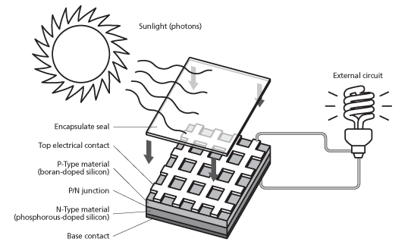

Figure 1 PV Panel system representation

A PV module contains the PV cells connected in series. To obtain a better yield, multiple PV modules are connected in series and others in parallel into what is called a PV Array.

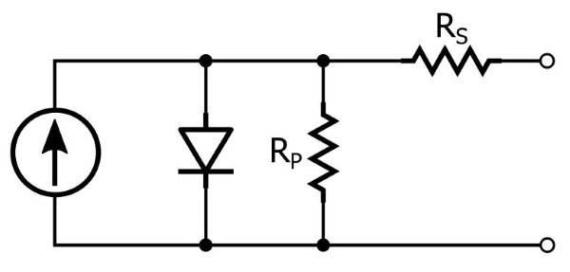After analyzing the behavior of the PV cell, Keim R. (2018) draws this equivalent circuit where RP is called the parallel resistance and RS is called the series resistance:

Figure 2 PV cell equivalent circuit

To get back to the PV cell’s performance, having it as polycrystalline as opposed to monocrystalline won’t affect the power generated too much. The big difference lies in the manufacturing of the two types of cells, polycrystalline are more prone to manufacturing defects which means statistically less working PV cells at any point in time (Sendy A., 2017). We should also keep in mind that the PV technology generated DC power that needs to be converted to AC to be used in homes. Another factor that should be considered power that the system will generate. First to explain how power should be read, if a panel generates X Watts of power, then in one hour of sunshine it would have generated X Watt-hours. This tells us that Watt-hours (Wh) represent the power generated in one hour of operation as opposed to Watts (W) which represents the power generated now. When talking about solar power, we can’t avoid mentioning the fact that power generated isn’t constant throughout the day. The concept of Watts-peak tells us the maximum possible power generation at direct sunlight (Solar Mango, 2015).

Samlexsolar (1991) discusses the power formula when varying the load (from a short circuit, all the way to an open circuit) at the PV cell’s terminals. This is also called the I-V curve generated under Standard Test Conditions (STC) meaning at direct sunlight and at system temperature of 25o C (Figure 3).

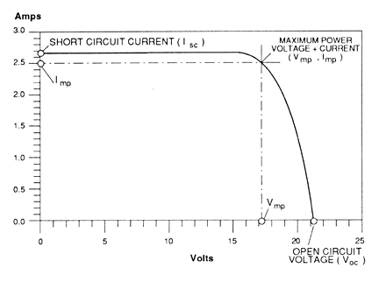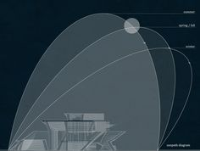

Figure 3 I-V curve plot

Figure 4 Sun path in Lebanon

One way to overcome the problem of varying sunlight exposure causing less power generation would be to maximize the time the system is at its Watts-peak. This is done by forcing the device to always face the sun (when it’s daylight). The path the sun takes over our head changes during each season. We can overcome that by changing the inclination of the device. That’s the project we are working on here minus the inclination which we assumed should be from 20o to 30o ideally in Lebanon (Figure 4).

# Regular Breadboard Implementation

As a solution to the problem, we built a circuit using only equipment worked on in the Lab. The circuit is shown below:

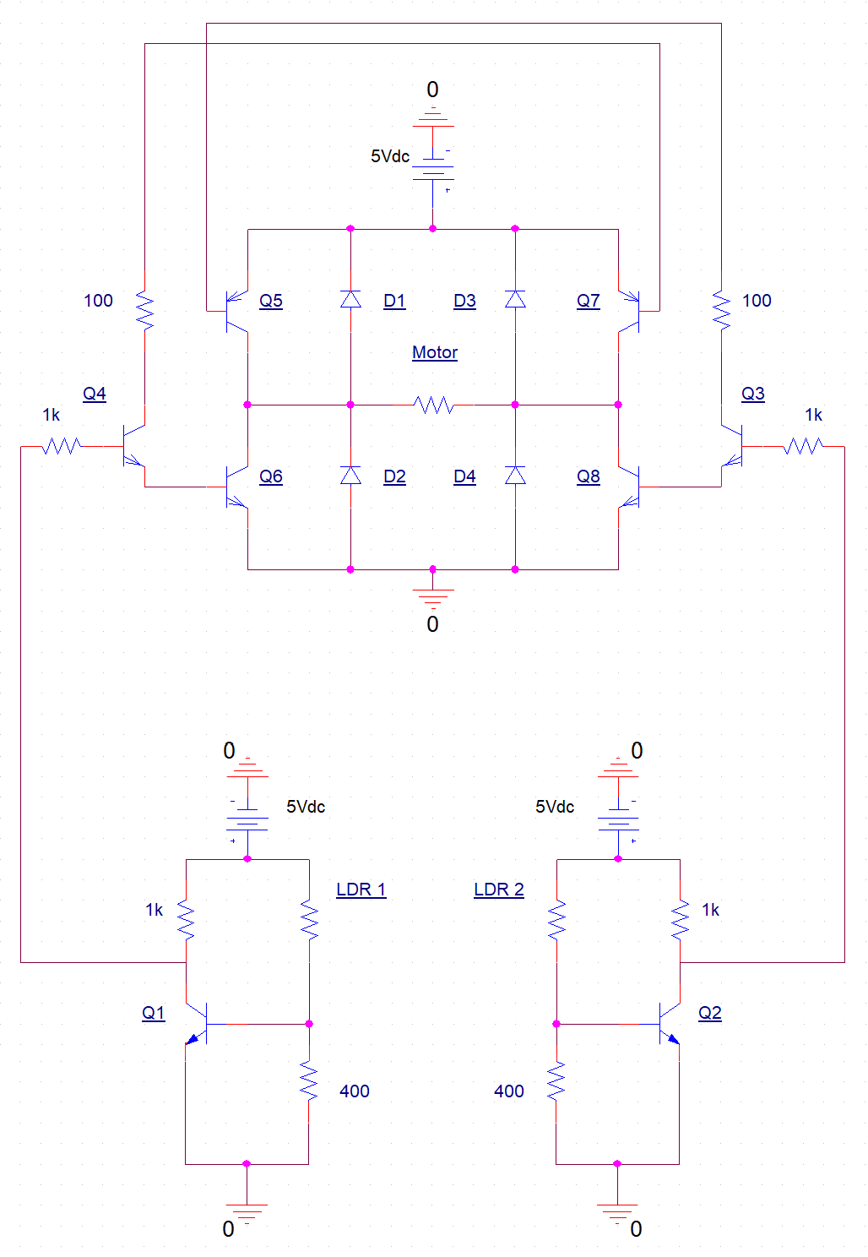

Figure 5 Solution circuit schematic

The circuit previously shown is divided into two main stages which we call the LDR stage (lower part of the circuit), and the motor stage (higher part of the circuit):

* 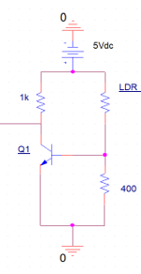**LDR Stage:**

It is basically two switches controlled using two LDRs. When the resistance of the LDR increases, the voltage division at the base of the NPN transistor, PN2222A *which the datasheet is in Appendix A*, forces VB (VBE since the emitter is connected to ground) to decrease thus switching the voltage at the collector node which in turn controls half the motor stage that will be explained next. The resistors were chosen through trial and error to match the variation of our specific LDR resistance.

Figure 6 LDR stage schematic

* **Motor Stage:**

This stage is simply an H-Bridge controlled by the LDR stage and two NPN transistors which turns on the diagonal NPN and PNP transistors of the H-Bridge from each side, passing the current from one side or the other thus switching the polarity of the voltage drop at the motor’s terminals. The PNP transistors used are 2N3906 of *which the datasheet is in Appendix B*. The diodes used are 1N4001*, its datasheet is in Appendix C*, they are added as protection for the transistors. On the two next pages we will explain the modes of operation of the H-Bridge.

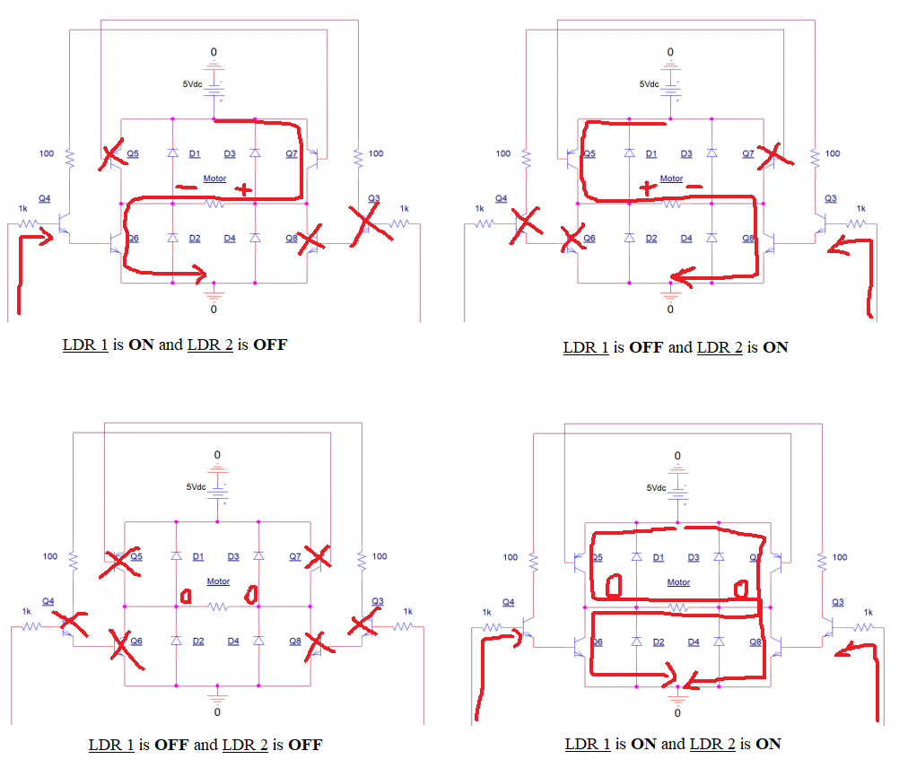

Figure 7 Visualization of the modes of operation of the H-Bridge

The table below more clearly shows theses modes of operation:

Table 1 H-Bridge modes of operation

|  |  |  |
| --- | --- | --- |
| **Motor rotation** | **Left terminal** | **Right terminal** |
| Forward | Vcc | GND |
| Reverse | GND | Vcc |
| Idle (Respectively) | Vcc **or** GND | Vcc **or** GND |

This H-Bridge is used to power a DC motor that converts electrical power into mechanical energy to rotate the solar panel.

For this project we used a regular DC motor that runs between 1V and 5V and has an internal resistance of 0.62Ω (calculated using V=RI). To calculate the torque of the motor at hand we used the formula PROT = M.ѡ where M is the torque. We found M = 139 mNm. The calculated torque seems to be enough to turn a small sized solar panel or the cardboard mock panel we used for the demonstration.

# Perforated Breadboard Implementation

We started-off drawing the components to scale, to choose the size of the breadboard we were going to use. We also added to the design a 100nF capacitor in parallel with the motor as protection. Then, we had to choose the tin/lead ratio of solder. After extensive research we found that 60/40 would be as close to ideal as possible since having more tin means a lower melting point for the solder. That was important because our soldering iron wouldn’t heat up to our desired temperature. Everything ended up working as expected as seen in the pictures below:

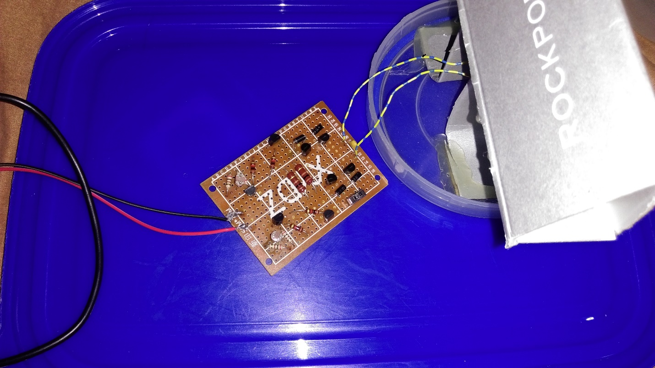

Figure 8 Perforated breadboard design (Front)

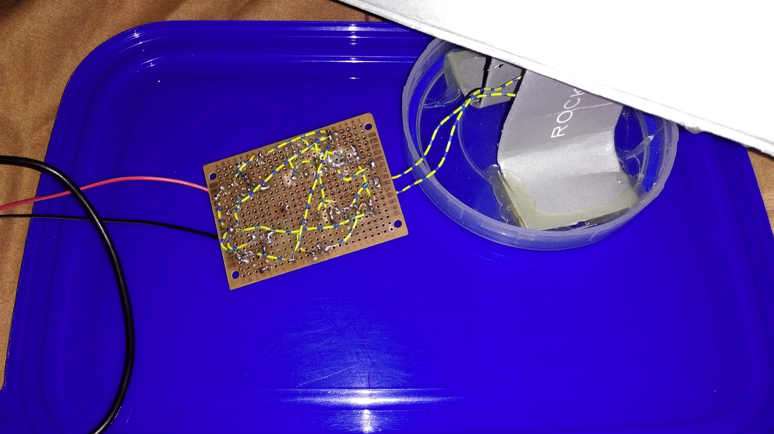

Figure 9 Perforated breadboard design (Back)

# Results and Testing

To test the design, we had to try out all inputs to the system and observe the output. First, we placed the whole device under bright light and watched to see if the motor would turn. As expected, the motor didn’t because both LDRs were under the same light exposure which causes the voltage drop on the motors terminals to be equal to zero. The same happens if both are covered. When we cover the first LDR, the motor started spinning forward, then when we switched cover to the second LDR, the motor spun in reverse. The design was working exactly as it should.

# Conclusion

To conclude, the prototype solar tracker we attempted was a success. The device was able to help the panel face the sun thus increasing the time the panel is generating the Watts-peak power. The is a big step into harvesting the sun’s energy to the fullest, but in the future, it would be possible to add to our design inclination mobility to maximize the rays of sun that are hitting the PV cells perpendicularly for a better power yield and a longer use of home electronics and appliances.

# References

* Blakers A. (2013, March 26). ***Explainer: what is photovoltaic solar energy?* Retrieved from** <https://theconversation.com/explainer-what-is-photovoltaic-solar-energy-12924>
* Samlexsolar. (1991). *Solar (Photovoltaic) Systems*. Retrieved from <https://www.samlexsolar.com/learning-center/solar-systems.aspx>
* Keim R. (2018, May 30). *The Circuit Designer’s Guide to Photovoltaic Cells for Solar-Powered Devices.* Retrieved from <https://www.allaboutcircuits.com/technical-articles/circuit-designer-guide-to-photovoltaic-cells-solar-powered-devices/>
* Sendy A. (2017, August 23). *Pros and Cons of Monocrystalline vs Polycrystalline solar panels*. Retrieved from <https://www.solarreviews.com/blog/pros-and-cons-of-monocrystalline-vs-polycrystalline-solar-panels>
* Solar Mango. (2015). *Watt Peak (Wp) – Definition, Glossary, Details – Solar Mango.* Retrieved from <http://www.solarmango.com/dictionary/watt-peak>

# Appendices

## Appendix A – PN2222A (NPN BJT)

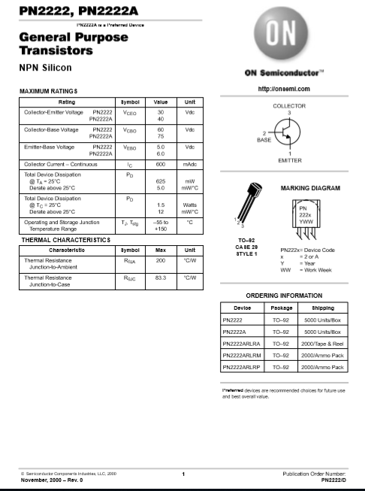

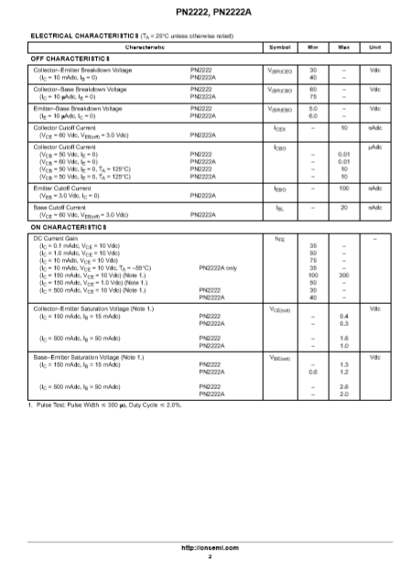

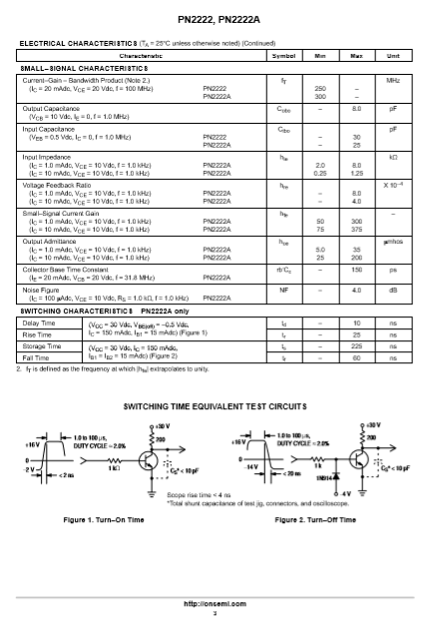

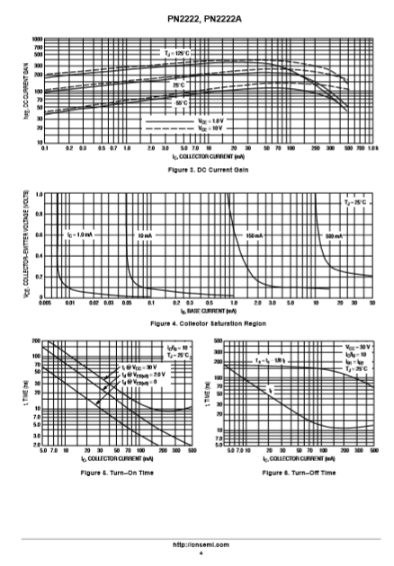

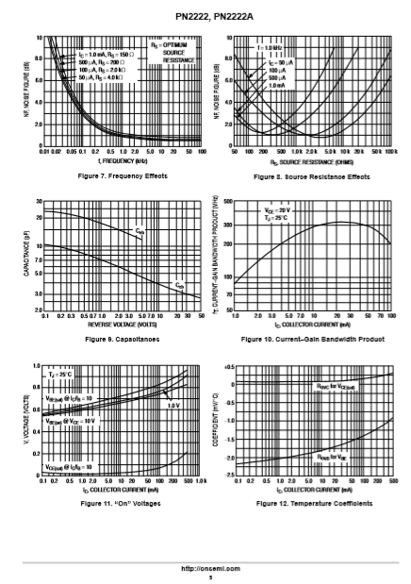

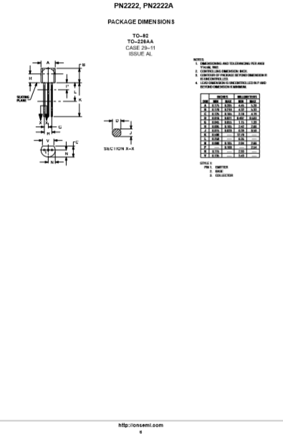

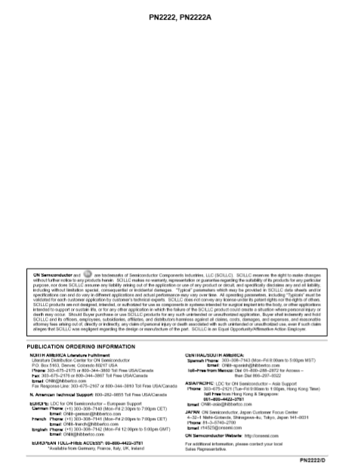

## Appendix B – 2N3906 (PNP BJT)

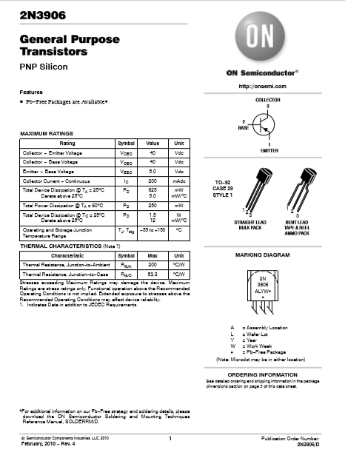

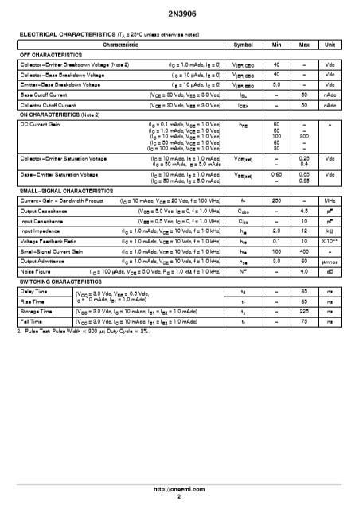

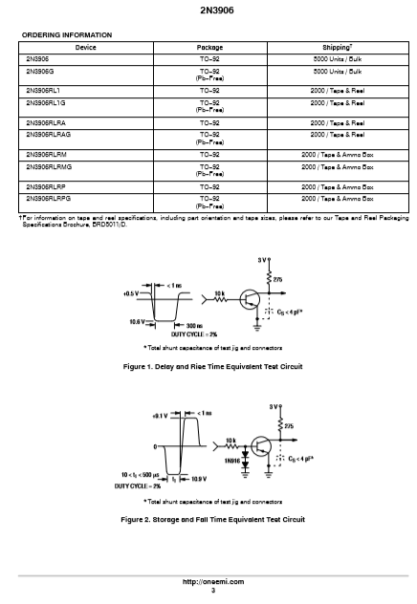

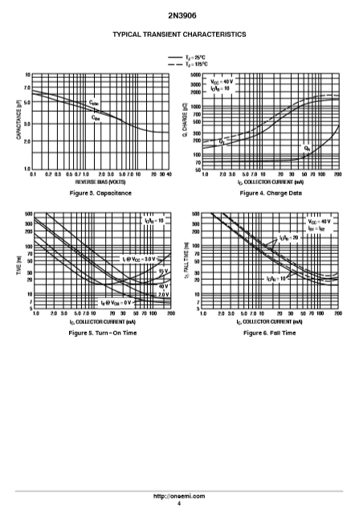

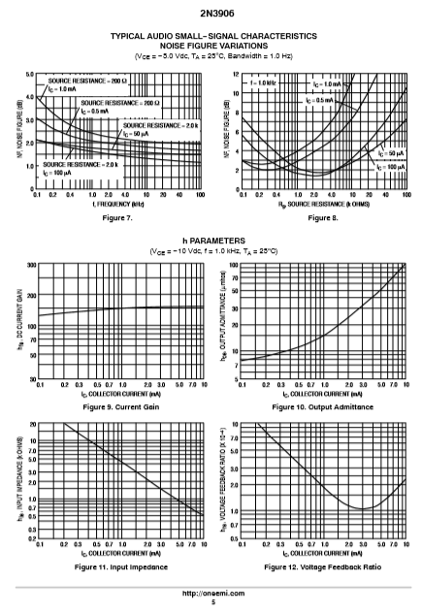

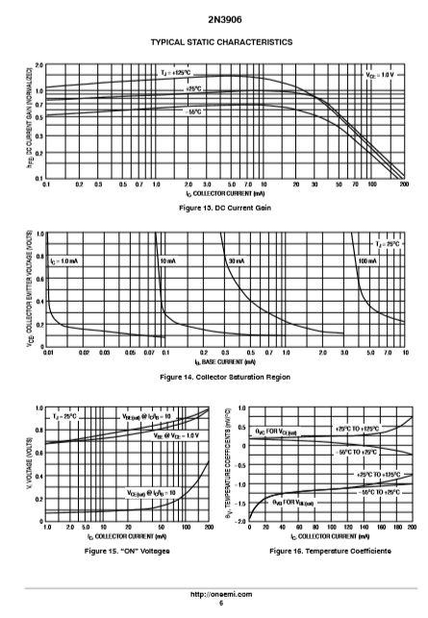

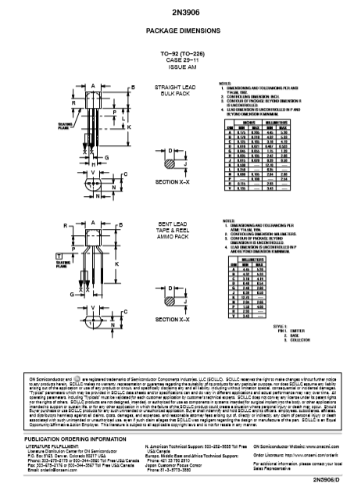

## Appendix C – 1N4001 Diode

